**Weather Data Analysis Report**

**1. Anomalies and Patterns**

* **Outliers:** Box plots revealed significant outliers in temperature, humidity, and wind speed, potentially due to data entry errors or extreme weather events.

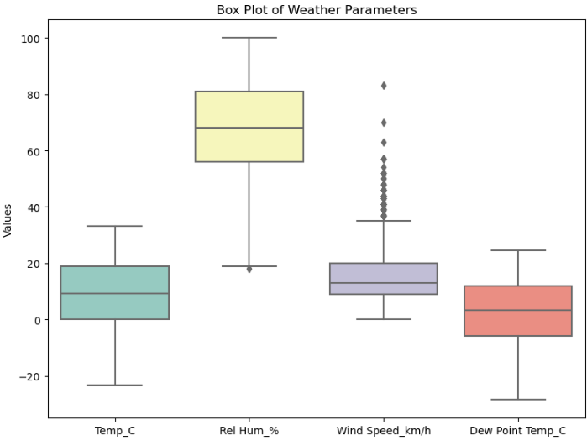

* **Patterns:** Histograms and KDE plots visualized the distribution of key weather parameters, allowing you to see how the data is spread.

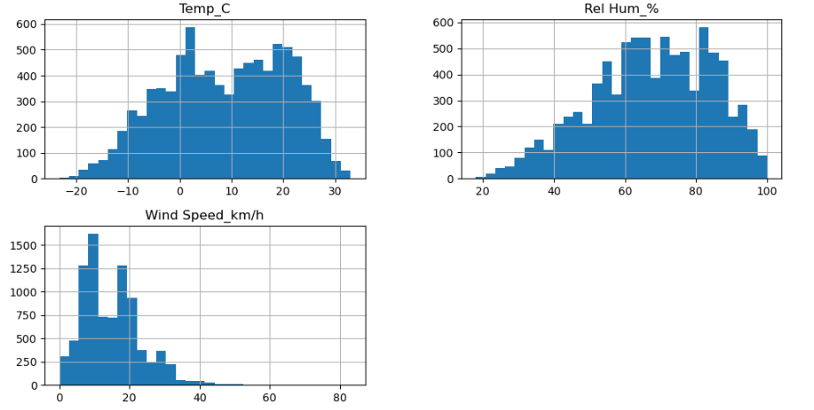

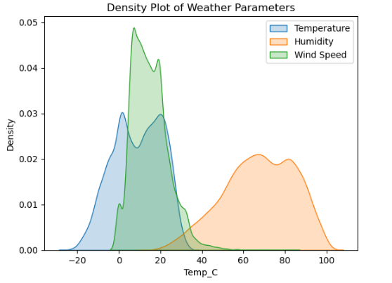

* **Seasonal Trends:** Temperature and humidity show clear seasonal variations, with higher temperatures in summer and higher humidity in rainy seasons.

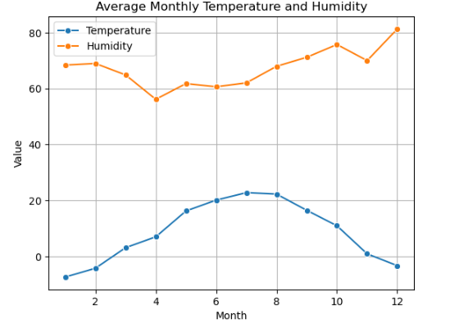

**2. Key Insights**

* **Temperature and Humidity**: Notable seasonal patterns, with higher temperatures and humidity in specific months.
* **Wind Speed**: Variable patterns with some months showing higher wind speeds.

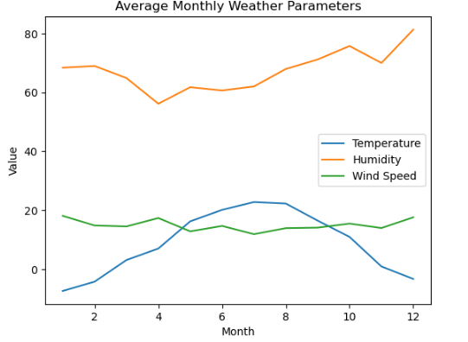

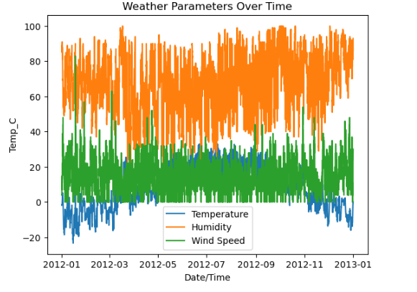

**3. Practical Applications**

* **Weather Prediction**: Seasonal patterns can be used to improve forecast accuracy.
* **Anomaly Detection**: Helps in identifying and preparing for extreme weather conditions.

**4. Recommendations**

* **Long-Term and Geographical Analysis:** Further analysis should include long-term trends and geographical variations.
* **Additional Data**: Incorporate historical and geospatial data for a more comprehensive analysis.